(Approx. 1854 words)

President's Corner
by Greg Skalka
What the Heck is That, and Why Didn’t I Do This Before?
Drive Light newsletter
www.uchug.org
president (at) uchug.org

The world is full of interesting things. As an engineer, I am usually in the habit of analyzing everything I see. Occasionally I will find something I cannot quite figure out initially, but often with a little help, it may make sense.

We all at times get in the habit of doing things a certain way. Even when it has become inconvenient or more costly, we often stick to our old ways despite having considered better solutions. It sometimes takes reaching a tipping point before we decide to try a new method, and often later wonder why it took us so long to change.

What the Heck Is That?

I love little tech gadgets. I buy a lot of little (meaning relatively inexpensive) things just on speculation, thinking that they might be useful. If they are not, at least I will have probably learned something. I am especially attracted to items on sale or that appear to be a bargain.

I buy a lot of USB Flash memory devices - after all, who cannot use more digital storage capacity? I have bought all sorts and styles of USB drives. Some have caps over the USB type A male connector for protection. Some act like a ball-point pen - the connector is concealed in the case and slides out for access. Some are large and some are tiny, not much bigger than the USB connector. I have some that are made of metal, though most have plastic bodies. Some have swivel covers, and some have no cover for the connector at all.

I bought one a while back that I thought was unique - a Patriot Stellar Lite 32 GB MicroUSB / USB 2.0 Flash Drive. (Photo 1) It has a standard USB type A on one end and a USB micro on the other (Photos 2 & 3). It was advertised to work with both PCs (the standard type-A end) and Android mobile devices (the USB micro end), assuming the mobile device supported USB OTG (On-The-Go).
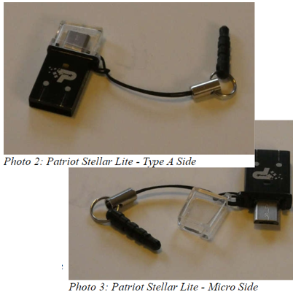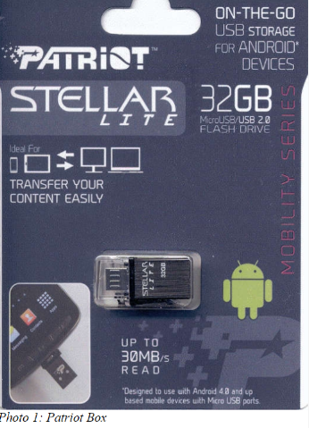

I bought this drive thinking I could easily transfer files between my computers and my Android tablet, but I found, in reality, I had little need to do that. It turns out that I seldom use my Android tablet at all. It is too big to carry around, and at 9” is too small to be comfortable for a lot of reading. With the touchscreen, it is too difficult to use for extensive writing, and adding a Bluetooth keyboard and mouse results in the equivalent of an underpowered netbook (remember those?) with some assembly required. My tablet really only served as a gateway device to my Chromebooks and smartphone.

I love my Chromebooks; they are lightweight, small but big enough to be useable, fast booting, and are great as an internet access device. They don’t have much internal storage as I only buy the original, inexpensive kind (those new Chromebooks with large screens, powerful processors and lots of storage are just Chrome OS laptops), so I need to keep SD cards and USB Flash drives with them. Since that Patriot Stellar Lite drive was small and provides less of a lever to catch and break off when plugged in, I assigned it to Chromebook duty.
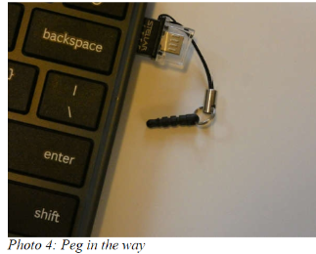
That is when I began thinking - what the heck is that little peg on the cord that came with the drive?

The cord obviously keeps the cap for the USB micro side from getting lost, but what is with the funny peg? It kept getting in the way under that side of the Chromebook.
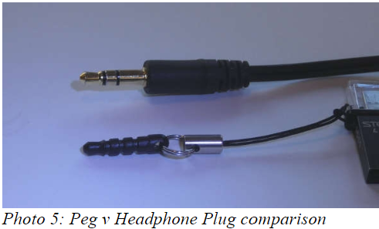
I was almost going to cut it off when my wife mentioned what it must be for. She suggested it would plug into the headphone jack, and thus retain the drive when it was unplugged.
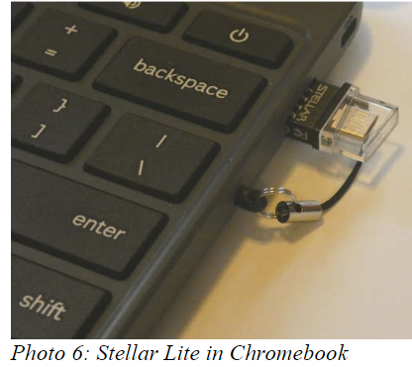

I tried this, and it worked (at least for the USB port on that side of the Chromebook).

I tried it on my smartphone and it worked as well. (I do not know if it is a necessity, but it must be what the manufacturer of the Flash drive intended.
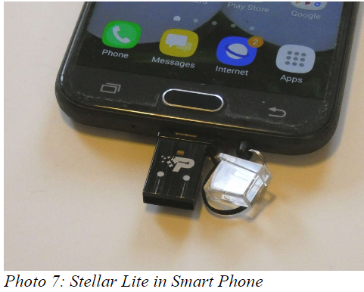
Mystery solved!

Why Didn’t I Do This Before?

I started regularly reading the newspaper at a young age. I have subscribed to the local paper since moving to San Diego in 1982. While I still get news from the radio and television, the newspaper has always been a trusted source, a familiar format, and my favorite way to stay informed. When internet news came along, I was ahead of many in questioning how accurate and factual the information was.

I do not often get to read books (or technical manuals, like Mr. Scott from the original Star Trek) for entertainment, but I try to keep up with the newspaper. I am too busy in life right now to succeed in this, however, and am usually days or weeks behind the current issue. Others might discard the paper after a day or so without reading it, but I find much more value in it than just the headline stories. I usually get all the front-page news I need in the little bit of local and national evening TV news broadcasting my wife has on when I get home, or on the radio during my commute. It is the more timeless articles of local, regional, and national issues in the newspaper that I find of most interest. The comics have always been worth the price to me as well.

While I have never had any real problems with the quality or content of the product, it is the price that has given me the hate in my love-hate relationship with the newspaper in the last few decades. Long ago the subscription was a fixed, advertised amount per period that had only reasonable increases over time. Then the newspaper appeared to adopt the pricing philosophy of the cable and satellite TV industry, not “what the market will bear," but what I will call “whatever the individual customer will bear." In this business model, customers don’t all pay the same price, and pricing is often not well advertised. Low introductory offers are available for new customers, but these rates soon increase until customers complain or cancel. Customer loyalty seems to be an undervalued trait.

I’m fine with reasonable price increases over time, in line with the general cost of living, but I still have a spreadsheet I generated in 2014 that showed I’d seen a 140% increase in my newspaper subscription cost over the prior three years. Calling and complaining got it reduced by 25%. Then I spoke with a friend in another part of town that got the same paper by paying 1/2 what I did. This price battle with the newspaper went on for years, but there was not much I could do since I had no acceptable alternative.

Though reading the paper was something I enjoyed, it was also a source of household discord. My wife is much like Mary Poppins (practically perfect in every way), and though she did read the newspaper (at least some of the time), she did not like the way I read it. She felt that once the sun had set on an edition it should be discarded; my piles of weeks-old papers were clutter to her. She blamed the newspaper ink on my hands for grime-marks on the kitchen table (where I read), the nearby furniture, and the walls near light switches. With no children or dogs in the household any longer to blame, I had to be the culprit. The physical paper was also a nuisance when we traveled, as we had to arrange for a neighbor to collect it each day (I didn’t want to stop the paper temporarily and let unscrupulous newspaper employees know our house would be vacant). I also had to go out on the driveway each morning and hopefully pick it up (and then call to complain when it was not there).

I had looked at the newspaper’s web site (Photo 8) as a digital alternative, but a hodgepodge of articles you have to search through is not what I wanted for getting my news. I wanted the same curated experience I got from the print paper, so a PDF version of the published paper would be the only acceptable digital substitute. Even then I was not sure I would be satisfied without the physical part of the newspaper experience.

Finally, after another price increase and another reading of the riot act about my piles of papers from my wife last fall, I seriously investigated the digital edition of the newspaper (it was included in our paper subscription anyway). I found you could read a reproduction of the paper on their web site (with a viewer I found less than ideal), and you could also download a PDF version. With the digital-only subscription costing 1/4 of what we were paying for print, I finally was motivated to cancel the paper version and went digital-only. No more trips to the driveway (or to the neighbor’s after a vacation), and no more late (or wet) papers or tips to a delivery person.

Unfortunately, I’ve yet to figure out how to download the PDF version from their site successfully with a Chromebook. I now download on a Windows computer to my small USB Flash drive and read them on my Chromebook at the kitchen table (or wherever). The papers can pile up on my Flash drive without my wife complaining of clutter. She says the household grime level has gone down as well, but I am suspicious of the sudden improvement, which may just be coincident with cleaning for the holidays. I have heard it said (probably by a woman) that men are bears with clothes, so I may be accused of having my hand in the honey jar yet in the future.

I have tried reading the PDF paper on my smartphone, (Photo 9) but it is way too difficult on the small screen. I have to scroll around to show only a small segment of a column on the screen to satisfy my old eyes (Photo 10). With the Chromebook, I can read when viewing the full-page width, and can still enlarge a bit more if necessary one day (something not possible with real paper).

I’ve found I’ve adapted well to reading the PDF newspaper on my Chromebook and now don’t miss the paper version at all (though I might when my stock of old papers I lay out when cleaning my bike chain is used up). Digital technology has improved my life yet again. I suspect I will still have to watch my subscription charges carefully, but it will, in any case, be a lot less than for having a real paper delivered and is better for the environment. With the digital-only subscription, I now look back at my physical paper days and wonder why I didn’t do this before?

